Assignment 01

Date:- 16/1/2025

Assignment title:- Installation, configuration & testing of MySQL

Installation :-

To install mysql-server on ubuntu, Run the following commands

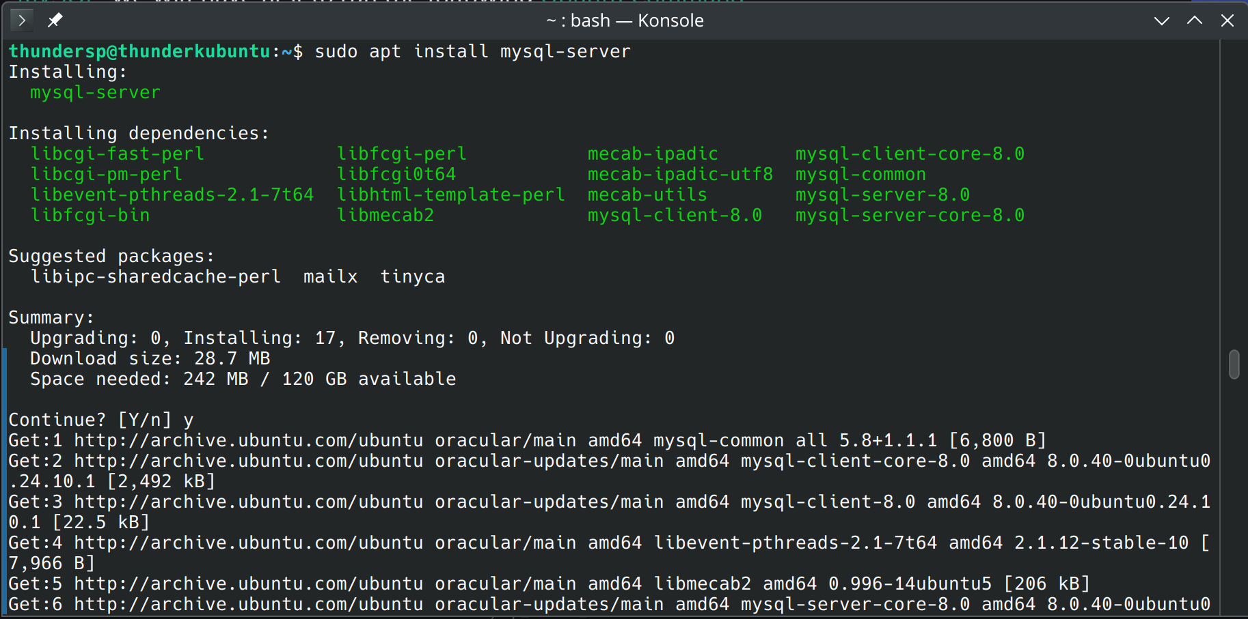  
Verify the install and set passwd:-

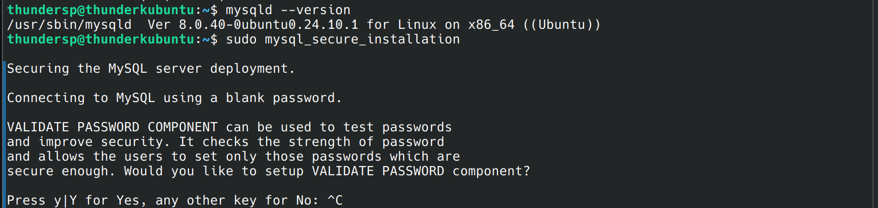  
Showing Database and DML on the New Tables:-

